In accordance with RRS Part. 7, 89.1(d) the organizing authority for all Class Championships and Sanctioned Regattas is the Snipe Class International Racing Association. Event Hosts (affiliated clubs or organizations) shall use these Sailing Instructions for all Championship and Sanctioned regattas. The Principal Race Officer (PRO) for the regatta shall fill in the appropriate information where requested as indicated by <___> or delete sections not relevant. Specific advice and directives are bracketed [*--*]. No additions or deletions to these instructions shall be permitted to alter the intent of the Class rules. No additions or changes shall be made without the prior approval of the regatta SCIRA Representative.

SAILING INSTRUCTIONS
SNIPE CLASS INTERNATIONAL RACING ASSOCIATION

<Name of the Regatta>
<Name of Deed of Gift Trophy>
<Date>
<Name of Yacht Club>
<Location>

[NP] denotes a rule that shall not be grounds for protests by a boat. This changes RRS 60.1

1 RULES
1.1 The regatta is governed by the rules as defined in the Racing Rules of Sailing (RRS). Other documents that govern the event under RRS Definition Rule (g) are listed in Notice of Race.

2 CHANGES TO SAILING INSTRUCTIONS
2.1 Any change to the sailing instructions will be posted before <insert time> on the day it will take effect, except that any change to the schedule of races will be posted by <insert time> on the day before it will take effect.
2.2 Any change or amendment to the Sailing Instructions shall be approved with the SCIRA Representative.

3. CODE OF CONDUCT
3.1 [DP] Competitors and support persons shall comply with reasonable requests from race officials.
3.2 [DP] Competitors and support persons shall <place advertising provided> by the organizing authority with care, seamanship, in accordance with any instructions for its use and without interfering with its functionality.

4 SIGNALS MADE ASHORE
4.1 Signals made ashore will be displayed at <Insert location>.
4.2 When the “AP” race signal is displayed ashore, ‘1 minute’ is replaced with ‘not less than <Insert number of minutes> minutes’ in the race signal “AP”. This changes Race Signals.
4.3 [DP] Flag D with one sound means ‘Boats shall not leave the [harbour][shore] until this signal is made. The warning signal will not be made before the scheduled time or less than <number> minutes after flag D is displayed.

5 SCHEDULE OF RACES
5.1 Dates of racing:
Date | Time of Warning Signal
______ | ________ | Practice race
______ | ________ | Racing
______ | ________ | Racing

5.2 No more than 2 races shall be sailed per day, unless to recover lost races. For Master events, no more than 2 races shall be sailed per day.
(OR)
5.2 When 3 races are scheduled in a day (according to RoC 5 Race Schedule, for Level 1 and Level 2 Regattas), the warning signal of a fleet or group for the third race of the day will not be displayed if the total time of racing has been more than two (2) hours. The total time of racing is the time of the first two (2) races combined. For the purposes of this rule ONLY, a race time will be the time for the first boat to sail the course.
5.3 The regatta shall consist of <insert number> races. [*Review the Deed of Gift that applies for your event*]
5.4 [*Optional*] The regatta shall consist of a qualifying and a final series according to the following system: <Insert system>.
5.5 There will be a competitor meeting before each series, at <insert time and location> and announced by two <insert type of sound signals>.

6 CLASS FLAGS
6.1 The official Class Flag shall be the Snipe Class flag, a Snipe silhouette on a white background.

7 RACING AREAS
7.1 Attachment <Insert number or letter> shows the location of racing areas.
(OR)
7.1 The Racing Area location is <describe location>.

8 THE COURSES
8.1 The diagrams below show the courses, including the approximate angles between legs, the order in which marks are to be passed. All course marks (except gates) shall be left to port.
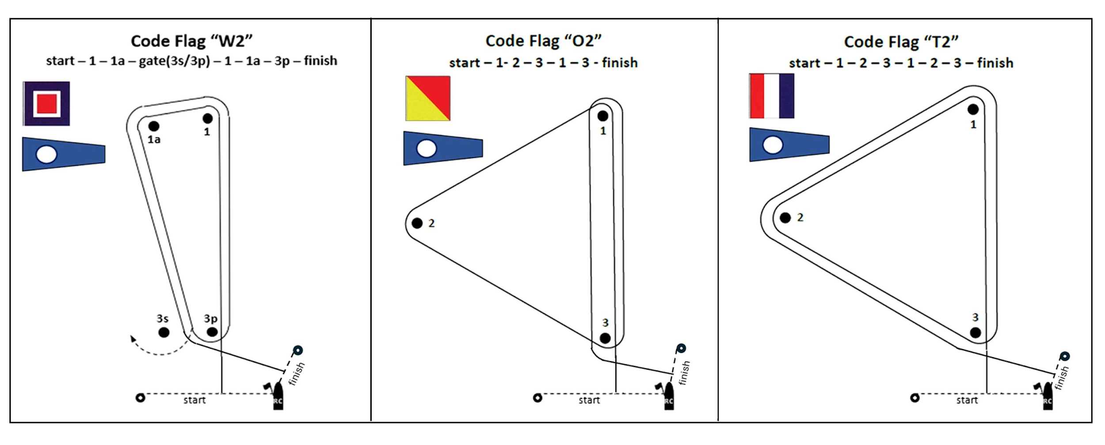
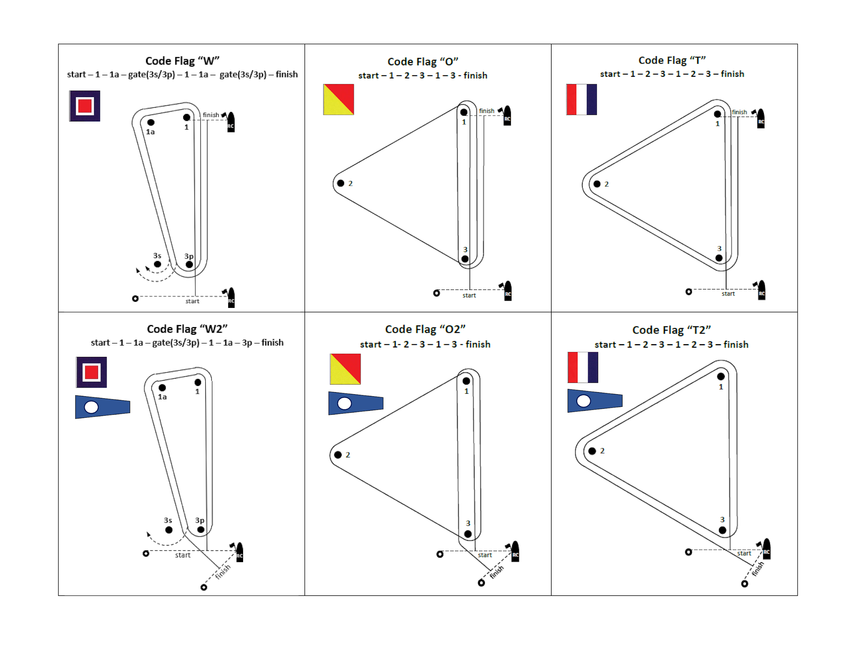
8.2 The course signal (code flag “W”, “T”, “O”, “W2”, “T2” or “O2”) shall be hoisted with one sound at least one minute before the warning signal. It will remain displayed for no less than five minutes after the start.
8.3 No later than the warning signal, the Race Committee signal boat may display the approximate compass bearing of the first leg.
8.4 If during a race the wind and/or wave action changes to the point where the selected course would be inadvisable (See Course Selection Diagram), the Race Committee shall change the course at any mark. A change of the type of course during the race shall be signalled displaying the new appropriate flag and accompanied by repetitive sounds before the leading boat has passed or rounded the mark.
8.5 A persistent wind variation of 20 degrees or more from the posted bearing during the first leg of a race shall be ground to apply RRS 32.1.
8.6 A persistent variation of 40 degrees or more off the posted bearing during the first lap shall be ground to apply RRS 32.1. For the purpose of this rule a lap means the rounding of mark 3 for the first time.
8.7 The number of legs in a race may be reduced (RRS code flag S) but at least 2 (two) windward legs of the course shall be completed. This changes the RRS 32.2. [*The SCIRA Representative shall be consulted.*]
8.8 A race shall not be started, or a race in progress shall be abandoned, in accordance with the Rules of Conduct for Conducting National and International Championships and the applicable Deed of Gift. This changes the RRS 32.1.

9 MARKS
9.1 Marks 1, 1A, 2, 3, 3s and 3p will be <Describe marks>.
9.2 New marks, as provided in instruction 12.1, will be <Describe new marks>.
9.3 The port-end starting mark will be:
a) a boat with an orange flag displayed;
(OR)
b) an inflatable rubber buoy <Describe new mark>.
9.4 The finishing mark will be:
- mark 1 for “W”, “O”, and “T” courses;
- <Describe mark> for “W2”, “O2”, and “T2” courses.
9.5 If one of the marks "gate 3s-3p" is not placed, or is not replaced as per RRS 34, the remaining mark shall be left to port. This changes the RRS 34.

10 AREAS THAT ARE OBSTRUCTIONS [*Optional*]
10.1 The following areas are designated as obstructions: <Describe obstruction areas>.

11 THE START
11.1 The starting line will be between a staff displaying an orange flag on the Race Committee vessel at the starboard end and:
a) a staff displaying an orange flag on the starting mark as provided in instruction 9.3 a).
(OR)
b) the course side of the starting mark as provided in instruction 9.3 b).
11.2 A boat starting later than 5 minutes after her starting signal will be scored Did Not Start without a hearing. This changes Appendices A4 and A5.
11.3 RRS 30.4 is changed so that it will be applied in fleets with more than 45 boats and after the 1st U Flag General Recall.
11.4 The Race Committee, after the finish of a race and before the warning signal of a subsequent one, will do its best to post on the Race Committee vessel a list of OCS, or ZPF, UFD or BFD boats. The failure of posting or an incomplete or wrong list will not be grounds for redress. This changes the RRS 61.1a)
11.5 To alert boats that a race or sequence of races will begin soon, the orange starting line flag will be displayed with one sound at least <insert time> minutes before a warning signal is made.

12 CHANGE OF THE NEXT LEG OF THE COURSE
12.1 To change the next leg of the course, the Race Committee will lay a new mark (or move the finishing line) and remove the original mark as soon as practicable. When in a subsequent change a new mark is replaced, it will be replaced by an original mark.
12.2 After the completion of the first windward leg of the race the remaining legs may be increased or decreased by not more than 30% of the original length. This changes the RRS 33. [*The SCIRA Representative shall be consulted on any change of course which affects its length.*]
12.3 If Mark 1 will be changed in courses “W” or “W2”, Mark 1A (offset) will no longer be a course mark.
12.4 Any adjustment of any leg of the course, while boats are racing, by moving mark(s) up to 010° in bearing and/or 0.1 nm in length will not be considered a change of course and requirements of RRS 33 will not apply. This changes RRS 33.

13 THE FINISH
13.1 The finish line will be between a staff displaying a blue flag on a Race Committee vessel and the course side of the finishing mark.
13.2 The A flag on the Race Committee vessel at the finish means that there will be no more races for the day.

14 TIME LIMITS AND TARGET TIMES
14.1 The races will be managed to last 60-75 minutes for the first boat to sail the course. A different time (shorter or longer) used to complete the race will not be ground for requesting redress. This changes 61.1(a).
14.2 The time limit for the first boat to complete the first lap is 40 minutes from the start. If the first boat fails to complete the first lap within 40 minutes the Race Committee shall abandon the race. For the purpose of this rule a lap means the rounding of Mark 3 (or passing the Gate 3s/3p) for the first time. This changes RRS 32.1.
14.3 The time limit for the first boat to sail the course shall be 1 hour, 30 minutes. Any boat finishing more than 20 minutes after the first boat finishes or failing to finish within 1 hour, 50 minutes from the start, whichever is shorter shall be scored Did Not Finish (DNF). This changes RRS 35, A4 and A5.

15 HEARING REQUESTS
15.1 Protest forms are available at the race office, located at <Insert URL or location>. Protests and requests for redress or reopening shall be delivered there within the appropriate time limit.
15.2 The protest time limit is 90 minutes after the last boat has finished the last race of the day or the Race Committee signals no more racing today, whichever is later.
15.3 Notices will be posted no later than 30 minutes after the protest time limit to inform competitors of hearings in which they are parties or named as witnesses. Hearings will be held in the protest room, located at <Insert location>, beginning at the time posted.
15.4 Notices of protests by the Race Committee, Technical Committee or Protest Committee will be posted to inform boats under RRS 60.2(a)(2).
15.5 Penalties for breaking Class Rules may be less than disqualification and according to the SCIRA Penalty Table.
15.6 Per Appendix N2.2, SCIRA reserves for itself the right and responsibility to decide issues of eligibility, measurement and equipment. SCIRA may refer any issue to the International Jury for advice.
15.7 For the purpose of RRS 63.5(d) the “authority responsible” is the Measurer of the event.
15.8 The Jury will abandon the race if, during a redress hearing, they conclude that the Race Committee did not follow Sailing Instructions 8.5, 8.6, 8.7, 8.8, 14.2 and 14.3. This changes the RRS 61.4(c).
15.9 A list of boats that have been penalized for breaking RRS 42, RRS 29.1(OCS) or 30.1(OCS) or 30.2(ZPF) 30.3(UFD), 30.4 (BFD), 16.1 and 16.2 will be posted on the Official Notice Board.

16 [NP][DP] SAFETY REGULATIONS
16.1 Before the warning signal of the first race of the day each boat is required to sail past the stern of the <insert description> Race Committee boat on starboard tack and verbally check in. The check-in boat will display a <insert flag description> while on station prior to the first warning signal. If no separate check-in boat is on station competitors will check in with the main Race Committee boat. When the Race Committee verbally acknowledges a boat’s <insert sail or bow> number, the check-in has been officially noted.
(OR)
16.1 Check-Out and Check-In: <Describe any Check-Out or Check-In Procedures>.
16.2 A boat that retires from a race shall notify the Race Committee as soon as possible.

17 REPLACEMENT OF CREW OR EQUIPMENT
17.1 The same crew shall race in all races, except for reasons satisfactory to the Race Committee. Requests for a change of crew shall be submitted in writing to the Chairman. Once a crew has been excused, he/she may not return for the balance of the series.
17.2 The same helmsperson shall sail all races and can be replaced after the first race only, and then only if he/she is obviously incapacitated. If a helmsperson is replaced the first race shall be the race dropped or scored DNC.
17.3 [DP] Substitution of hull, sails, appendages, and rig will not be allowed unless authorized in writing by the <name of committee>. Requests for substitution shall be made to the committee at the first reasonable opportunity, which may be after the race.

18 OFFICIAL VESSELS
18.1 Official vessels will be marked as follows: <Describe markings>.

19 [DP] RADIO COMMUNICATIONS
19.1 A boat that is racing shall not make voice or data transmissions and shall not receive voice or data communication that is not available to all boats, except in an emergency or when using equipment provided by the race committee.

20 [NP] [DP] TRASH DISPOSAL
20.1 Trash may be placed aboard support and Committee Vessels.

Signatures: [* The Sailing Instruction must be signed by the Race Committee Chairman or Principal Race Officer and also the SCIRA Representative*] <insert name> - Race Committee Chairman <insert name> - SCIRA Representative

Optional Addendum
(Large Fleets)

The Start:

11.1 Mid-line boat
11.1.1 The starting line shall be between an orange flag or shape on the Race Committee boat on the starboard line end and passing through an orange flag or shape on the mid-line boat and ending at the line flag or the course side of the port end starting mark. The mid-line boat is a starting mark surrounded by navigable water. Should the mid-line boat be removed, the line shall be defined by the previously described line ends.
11.1.2 For the purpose of RRS 29.1 and 30.1, the extensions of the starting line are beyond the port and starboard line ends.
11.1.3 RRS 31 is modified such that when a boat touches the mid-line boat and infringes RRS 30.1, she shall exonerate herself by completing one rounding of either line end and restarting.
11.1.4 The Race Committee may set a guidance marker on or below the starting line. If set, such a marker is neither a part of the starting line, nor a mark of the course.

