Standard Race Document Template

Event Hosts (affiliated Clubs or organizations) shall use this Notice of Race and the Class Sailing Instructions for all Championships. The regatta chairman or his/her designee for the regatta shall fill in the appropriate information were requested by <___> or delete it as appropriate. Additional comments and instructions are found in red, and they must be deleted. No additions or deletions to this Notice of Race shall be permitted to alter the intent of the Class rules or instructions. No additions or changes shall be made without the prior approval of the regatta SCIRA Representative.

RACE DOCUMENT - NOTICE OF RACE & SAILING INSTRUCTIONS
SNIPE CLASS INTERNATIONAL RACING ASSOCIATION
<name of the regatta>
<name of deed of gift>
<date>

ORGANIZING AUTHORITY:
<insert name of the affiliated club and National Authority>, in co-operation with the Snipe Class International Racing Association

Except in the titles, A term used in the sense stated in the RRS Definitions is printed in italics. A term used in the sense stated in the ERS is printed in bold.

[SP] denotes a rule for which a standard penalty may be applied by the race committee or technical committee without a hearing or a discretionary penalty applied by the International Jury with a hearing. (This changes rule RRS 63.1, A4 and A5).
[NP] denotes a rule that shall not be grounds for protests by a boat. (This changes RRS 60.1(a))

1 RULES
The regatta will be governed by:
1.1 The rules as defined in the Racing Rules of Sailing. (RRS)
1.2 The SCIRA Rules of Conduct for Conducting National and International Championship Regattas (RoC) available at https://www.snipe.org/images/2021/SCIRA_2021_Rules_of_Conduct_final.pdf
1.3 The Deed of Gift, available at http://www.snipe.org/class/deeds-of-gift.
1.4 [*Optional – if pertinent*] The RoC sections <insert the appropriate section> modified as specified in the Sailing Instructions.
1.5 [*Optional*] No national prescriptions will apply (OR) No national prescriptions will apply, except the following: <Insert prescriptions>
1.6 No drones are allowed closer than 500 m from racing areas from the Warning Signal for a race and after the last boat has finished the last race of the day. This does not apply to OA drones.
1.7 [*For regattas employing an international jury according appendix N*] The decision of the Jury will be final in accordance with RRS 70.5.
1.8 [*Optional*] RRS Appendix T will apply.
1.9 Appendix P will apply.
1.10 [*Optional*] RRS Rule 40 Personal Flotation Device applies at all times while afloat. (This changes RRS Preamble of Part 4)
1.11 If there is a conflict between languages the English will take precedence.

2 CODE OF CONDUCT [DP] [NP]
2.1 Competitors and support persons shall comply with reasonable requests from race officials.
2.2 Competitors and support persons shall place advertising provided by the organizing authority with care, seamanship, in accordance with any instructions for its use and without interfering with its functionality.

3 CHANGES TO THE RULES
3.1 Any change to the rules will be posted before <insert time> on the day it will take effect, except that any change to the schedule of races will be posted by <insert time> on the day before it will take effect.
3.2 Any change or amendment to the Race Document shall be approved with the SCIRA Representative.

4 COMMUNICATIONS
4.1 The online official notice board is located at <URL> (OR) <location>.
4.2 Except in an emergency or when using equipment provided by the race committee, a boat that is racing shall not make voice or data transmissions and shall not receive voice or data communication that is not available to all boats.

5 ELIGIBILITY AND ENTRY
5.1 This regatta is open to SCIRA registered boats for the current year, subject to any Deed of Gift restrictions.
5.2 Eligible boats may enter by completing online registration at <insert link> no later than <insert time and date>. Entries may be accepted after this date only with approval by the OA on a case-by-case basis.
5.3 Only boats that have completed all registration requirements will be allowed to compete. Note – completed registration includes payment of entry fee.
5.4 No crew shall be eligible to enter any Class championship race unless:
- they possess and present a current Class Membership Card, or
- SCIRA-issued equivalent, or
- shows as member in the SCIRA Official Online Database.
5.5 A skipper should be designated at the entry form.
5.6 The designed skipper must be at the helm while racing except in the event of an emergency involving the safety of the boat or crew.
[*For Championship Regattas requiring qualification: *]
5.7 All entrants shall be approved by the National Secretary affiliated with the skipper.
(OR)
[*For major International Championship Regattas that require qualification: *]
5.8 The crew shall establish with SCIRA their entry approval through their own National Secretary.

6 FEES
<insert entry fee, how/when to pay, and other info relevant (what is included –social events, camping etc.)>

7 SCHEDULE & FORMAT
7.1 Registration:
7.2 Initial Equipment Inspection: <include dates and time, specify in on site or in-house>
7.3 Schedule of Races: <Insert a table with the scheduled races with date and time>
7.4 <insert number> races are scheduled [*No more than 9 races shall be scheduled]
7.5 On the last day of racing no warning signal will be made after <Insert time>.
7.6 [*Optional*] When the entrants exceed <insert number> boats, the fleet may be split, and the regatta will consist of a qualifying series and a final series.
7.7 [*Optional*] The regatta shall consist of a qualifying and a final series according to the following system: <Insert system>.
7.8 To alert boats that a race or sequence of races will begin soon, the orange starting line flag will be displayed with one sound at least <insert time> minutes before a warning signal is made.
7.9 There will be a competitor meeting before each series, at <insert time and location> and announced by two <insert type of sound signals>.

8 EQUIPMENT INSPECTION
8.1 [DP] Initial Equipment Inspection: All boats shall be presented for inspection with the full equipment, including sails and personal flotation devices during the scheduled measurement. Boats and equipment shall be presented in a dry, clean, and salt-free condition. The Technical Committee or Race Committee may extend the Initial Equipment Inspection time.
8.2 The measurement certificate should be presented during the initial equipment inspection. (This changes RRS rule 78.2)
8.3 A boat may be inspected at any time for compliance with the Class Rules, notice of race and sailing instructions.
8.4 [DP] When instructed by a race official on the water, a boat shall proceed to a designated area for inspection.

9 REPLACEMENT OF CREW OR EQUIPMENT
9.1 The same crew shall race in all races, except for reasons satisfactory to the Race Committee. Requests for a change of crew shall be submitted in writing to the Chairman. Once a crew has been excused, he/she may not return for the balance of the series.
9.2 The same skipper shall sail all races and can be replaced after the first race only, and then only if he/she is obviously incapacitated. If a skipper is replaced the first race shall be the race dropped or scored DNC.
9.3 [DP] Substitution of hull, sails, appendages, and rig will not be allowed unless authorized in writing by the <name of committee>. Requests for substitution shall be made to the committee at the first reasonable opportunity, which may be after the race.

10 ADVERTISING
10.1 Boats may be requested to display advertising chosen and supplied by the organizing authority.

11 VENUE
11.1 Races will be sailed <insert location of racing area>

12 SIGNALS MADE ASHORE
12.1 Signals made ashore will be displayed at <Insert location>.
12.2 When the “AP” race signal is displayed ashore, ‘1 minute’ is replaced with ‘not less than <Insert number of minutes> minutes’ in the race signal “AP”. (This changes Race Signals)
12.3 [DP] [NP] Flag D with one sound means ‘Boats shall not leave the [harbour][shore] until this signal is made. The warning signal will not be made before the scheduled time or less than <number> minutes after flag D is displayed.

13 RACING AREAS
13.1 Attachment <Insert number or letter> shows the location of racing areas.
(OR)
13.1 The Racing Area location is <describe location>.

14 CLASS FLAGS
14.1 The official Class Flag shall be the Snipe Class flag, a Snipe silhouette on a white background.

15 COURSES
15.1 The diagrams below show the courses, including the approximate angles between legs, the order in which marks are to be passed. All course marks (except gates) shall be left to port.
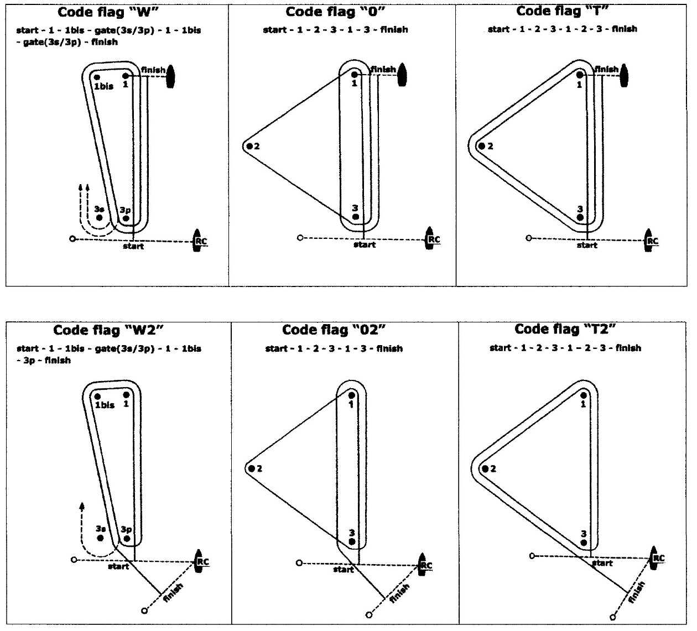

15.2 The course signal (code flag “W”, “T”, “O”, “W2”, “T2” or “O2”) shall be hoisted with one sound at last one minute before the warning signal. It will remain displayed for not less than five minutes after the start.
15.3 No later than the warning signal, the Race Committee signal vessel may display the approximate compass bearing of the first leg.
15.4 If during a race the wind and/or wave action changes to the point where the selected course would be inadvisable (See Course Selection Diagram), the Race Committee shall change the course at any mark. A change of the type of course during the race shall be signalled displaying the new appropriate flag and accompanied by repetitive sounds before the leading boat has passed or rounded the mark.
15.5 A sustained wind variation of 20 degrees or more from the posted bearing during the first leg of a race shall result in the race to be abandoned and re-sailed or abandoned. (This changes the RRS 32.1)
15.6 A sustained wind variation of 40 degrees or more from the posted bearing during the first lap shall result in the race being abandoned and re-sailed or abandoned. For the purpose of this rule, a lap means the rounding of mark 3 (or passing the gate 3s-3p) for the first time. (This changes the RRS 32.1)
15.7 The number of legs in a race may be reduced (RRS code flag S) but at least 2 (two) windward legs of the course shall be completed. This changes the RRS 32.2. [*The SCIRA Representative shall be consulted.*]
15.8 The wind speed ranges shall be no less than 5 knots and not exceed 23 knots or in accordance with the Rules of Conduct for Conducting National and International Championships and the applicable Deed of Gift. (This changes the RRS 32.1)

16 MARKS
16.1 Marks 1, 1bis, 2, 3, 3s and 3p will be <Describe marks>.
16.2 New marks, as provided in instruction 21, will be <Describe new marks>.
16.3 The port-end starting mark will be:
a) a vessel with an orange flag displayed;
(OR)
b) an inflatable rubber buoy <Describe new mark>.
16.4 The finishing mark will be:
- mark 1 for “W”, “O”, and “T” courses;
- <Describe mark> for “W2”, “O2”, and “T2” courses.
16.5 Except at a gate, a Race Committee vessel signalling a change of a leg of the course is a mark as provided in SI 21
16.6 If one of the marks "gate 3s-3p" is not placed, or is not replaced as per RRS 34, the remaining mark shall be left to port. (This changes the RRS 34)

17 AREAS THAT ARE OBSTRUCTIONS [*Optional*]
17.1 The following areas are designated as obstructions: <Describe obstruction areas>.

18 SAFETY REGULATIONS [NP][DP] [SP]
18.1 Before the warning signal of the first race of the day each boat is required to sail past the stern of the <insert description> Race Committee vessel on starboard tack and verbally check in. The check-in vessel will display a <insert flag description> while on station prior to the first warning signal. If no separate check-in vessel is on station competitors will check in with the main Race Committee vessel. When the Race Committee verbally acknowledges a boat’s <insert sail or bow> number, the check-in has been officially noted.
(OR)
18.1 Check-Out and Check-In: <Describe any Check-Out or Check-In Procedures>.
18.2 A boat that retires from a race shall notify the Race Committee as soon as possible.

19 THE START
19.1 The starting line will be between a staff displaying an orange flag on the Race Committee vessel at the starboard end and:
a) a staff displaying an orange flag on the starting mark as provided in instruction 10.3 a).
(OR)
b) the course side of the starting mark as provided in instruction 10.3 b).
19.2 A boat starting later than 5 minutes after her starting signal will be scored Did Not Start without a hearing. (This changes Appendices A4 and A5)
19.3 RRS 30.4 is changed so that it will be applied in fleets with more than 45 boats and after the 2nd General Recall for that race.
19.4 The Race Committee, after the finish of a race and before the warning signal of a subsequent one, will do its best to post on the Race Committee vessel a list of OCS, or ZPF, UFD or BFD boats. The failure of posting or an incomplete or wrong list will not be grounds for redress. (This changes the RRS 62.1(a))

20 CHANGE OF THE NEXT LEG OF THE COURSE
20.1 To change the next leg of the course, the Race Committee will lay a new mark (or move the finishing line) and remove the original mark as soon as practicable. When in a subsequent change a new mark is replaced, it will be replaced by an original mark.
20.2 Except at a gate, boats shall pass between the race committee vessel signalling the change of the next leg and the nearby mark, leaving the mark to port and the Race Committee vessel starboard. (This changes the RRS 28)
20.3 After the completion of first windward leg of the race the remaining legs may be increased or decreased by not more than 30% of the original length. This changes the RRS 33. [*The SCIRA Representative shall be consulted on any change of course which affects its length.*]
20.4 If Mark 1 will be changed in courses “W” or “W2”, Mark 1bis (offset) will no longer be a course mark.

21 THE FINISH
21.1 The finish line will be between a staff displaying a blue flag on a Race Committee vessel and the course side of the finishing mark.
21.2 The A flag on the Race Committee vessel at the finish means that there will be no more races for the day.

22 TIME LIMITS AND TARGET TIMES
22.1 The races will be managed to last 60-75 minutes for the first boat to finish. A different time (shorter or longer) used to complete the race will not be ground for requesting redress. (This changes RRS 62.1)
22.2 The time limit for the first boat to complete the first lap is 40 minutes from the start. If the first boat fails to complete the first lap within 40 minutes the Race Committee shall abandon the race. For the purpose of this rule a lap means the rounding of mark 3 (or passing the Gate 3s/3p) for the first time.
22.3 The time limit for the first boat to finish the race shall be 1 hour, 30 minutes. Any boat finishing more than 30 minutes after the first boat finishes or failing to finish within 2 hours from the start, whichever is shorter shall be scored Did Not Finish (DNF). (This changes RRS 35, A4 and A5)

23 HEARING REQUESTS
23.1 Protest forms are available at the race office, located at <Insert URL or location>. Protests and requests for redress or reopening shall be delivered there within the appropriate time limit.
23.2 The protest time limit is 90 minutes after the last boat has finished the last race of the day or the Race Committee signals no more racing today, whichever is later.
23.3 Notices will be posted no later than 30 minutes after the protest time limit to inform competitors of hearings in which they are parties or named as witnesses. Hearings will be held in the protest room, located at <Insert location>, beginning at the time posted.
23.4 Notices of protests by the Race Committee, Technical Committee or Protest Committee will be posted to inform boats under RRS 61.1(b).
23.5 The penalty for breaking rules in the SI marked with [SP] may be applied at the discretion of the Race Committee, without a hearing, and shall be the 5% scoring penalty for nearest race completed by the infringing boat but not worse than a DSQ. (This changes the RRS 63.1 and the Appendix A5)
23.6 Penalties for breaking Class Rules may be less than disqualification. (This changes 64.2)
23.7 Per Appendix N2.2, SCIRA reserves for itself the right and responsibility to decide issues of eligibility, measurement and equipment. SCIRA may refer any issue to the International Jury for advice.
23.8 For the purpose of RRS 64.4(b) the “authority responsible” is the Measurer of the event.
23.9 The Jury will abandon the race if, during a redress hearing, they conclude that the Race Committee did not follow Sailing Instructions 15.5, 15.6, 15.7, 15.8 and 19.1. (This changes the RRS 64.3)
23.10A list of boats that have been penalized for breaking RRS 42, RRS 29.1(OCS) or 30.1(OCS) or 30.2(ZPF) 30.3(UFD), 30.4 (BFD), SI 17.5 and 17.6 will be posted on the Official Notice Board.

24 SCORING
24.1 <insert number> races are required to be completed to constitute a series.
24.2 (a) When fewer than <number> races have been completed, a boat’s series score will be the total of her race scores.
24.3 (b) When from <number> to <number> races have been completed, a boat’s series score will be the total of her race scores excluding her worst score.
[*Unless specified in the event’s DoG, if 7 to 9 races are sailed, the worst race shall be excluded according to RRS 90.3 and Appendix A. If less than 7 races are scheduled, the race exclusion shall be specified in the NoR or SI. No race shall be excluded if 3 or less races are sailed.*]

25 SUPPORT PERSON VESSELS [NP][DP]
25.1 Between the preparatory signal and the starting signal, Support Vessels must be positioned at least 50 meters below the starting line. After the starting signal Support Vessels may follow the fleet, but only on the <port> (OR) <starboard> side of the course and must stay 50 meters from any mark.
25.2 Support Persons shall register at the Regatta Office and all support boats shall be identified <insert how to identify>.

26 DATA PROTECTION AND RIGHTS TO USE NAME AND LIKENESS
26.1 By participating in this event, competitors automatically grant to SCIRA, the organizing authority and the event sponsors the right, in perpetuity, to make, use, and show, at their discretion, any photography, audio and video recording, and other reproductions of them made at the venue or on the water from the time of their arrival at the venue, until their final departure, without compensation.

27 RISK STATEMENT
27.1 Competitors participate in the event entirely at their own risk. See RRS 3, Decision to Race. The OA will not accept any liability for material damage or personal injury or death sustained in conjunction with or prior to, during, or after the regatta.
27.2 Sailing is by its nature an unpredictable sport and therefore inherently involves an element of risk. By taking part in the event, each competitor and the responsible adult agree and acknowledges that:
a) They are aware of the inherent element of risk involved in the sport and accept responsibility for the exposure of themselves and their boat to such inherent risk whilst taking part in the event;
b) They are responsible for the safety of themselves, their boat and their other property whether afloat or ashore;
c) They accept responsibility for any injury, damage or loss to the extent caused by their own actions or omission;
d) Their boat is in good order, equipped to sail in the event and they are fit to participate;
e) The provision of a race management team, patrol boats and other officials and volunteers by the event organizer does not relieve them of their own responsibilities;
f) The provision of patrol boat cover is limited to such assistance, particularly in extreme weather conditions, as can be practically provided in the circumstances.

28 INSURANCE
28.1 Each participating boat shall be insured with valid third-party liability insurance with a minimum cover of <insert value> per incident or the equivalent.

29 PRIZES
<insert prize detail including Deed of Gift, if any>

30 QUALIFICATIONS FOR SUBSEQUENT EVENT
<insert detail for advancement criteria>

31 FURTHER INFORMATION
31.1 For further information please contact <insert name and contact information>

PRACTICAL INFORMATION (Not part of the Notice of Race)

SOCIAL: <detail, specifying what is included and what is not included in the entry fee>

SCIRA REPRESENTATIVE: <insert name and contact information>

REGATTA WEBSITE: <insert URL>

PRINCIPAL RACE OFFICER <insert name and contact information>

CHAIRMAN OF THE JURY <insert name and contact information>

CHARTER BOATS: <detail>

HOUSING: <detail>

