* 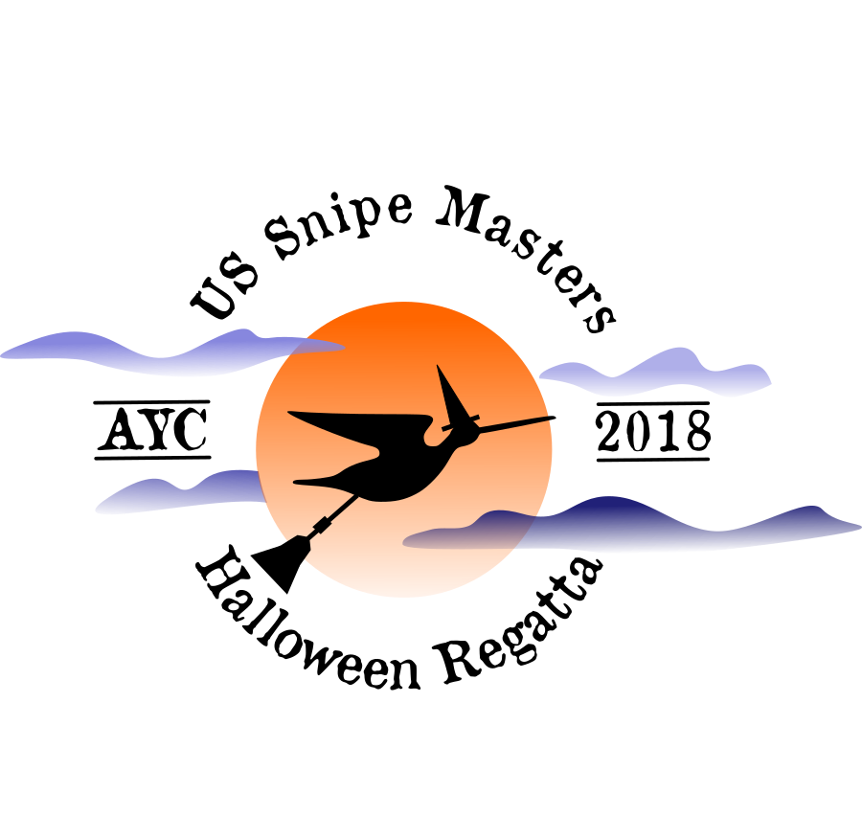
* IT’S NEVER TOO LATE ….
* TO SAIL A SNIPE

**SNIPE USA MASTERS NATIONAL CHAMPIONSHIP**

* **HALLOWEEN REGATTA**

**October 26 – 28, 2018**

**Atlanta Yacht Club**

* **This fall Snipe sailors of all ages will rally at the Atlanta Yacht Club to sail the Snipe USA Masters and the traditional AYC Halloween Regatta. The festivities will begin Thursday evening October 25th with a welcome cookout and party for the arriving Masters competitors. The Masters racing will start Friday afternoon with 2 races. On Friday evening the Halloween competitors join the Masters and will be welcomed with the traditional chili dinner and children’s Halloween party. On Saturday, after the AM Junior and Junior/Senior Regatta, and Sunday, the Masters and the Halloween competitors will sail together in 3 races. You can register for both events, or only one of them, and will be scored in each event based on your finishing place relative to those registered in each event. Yes, almost a two for one regatta!**
* **Saturday evening will be highlighted by our cooked-to-order steak or salmon dinner and the Monster Ball Costume Party featuring a live jazz band**

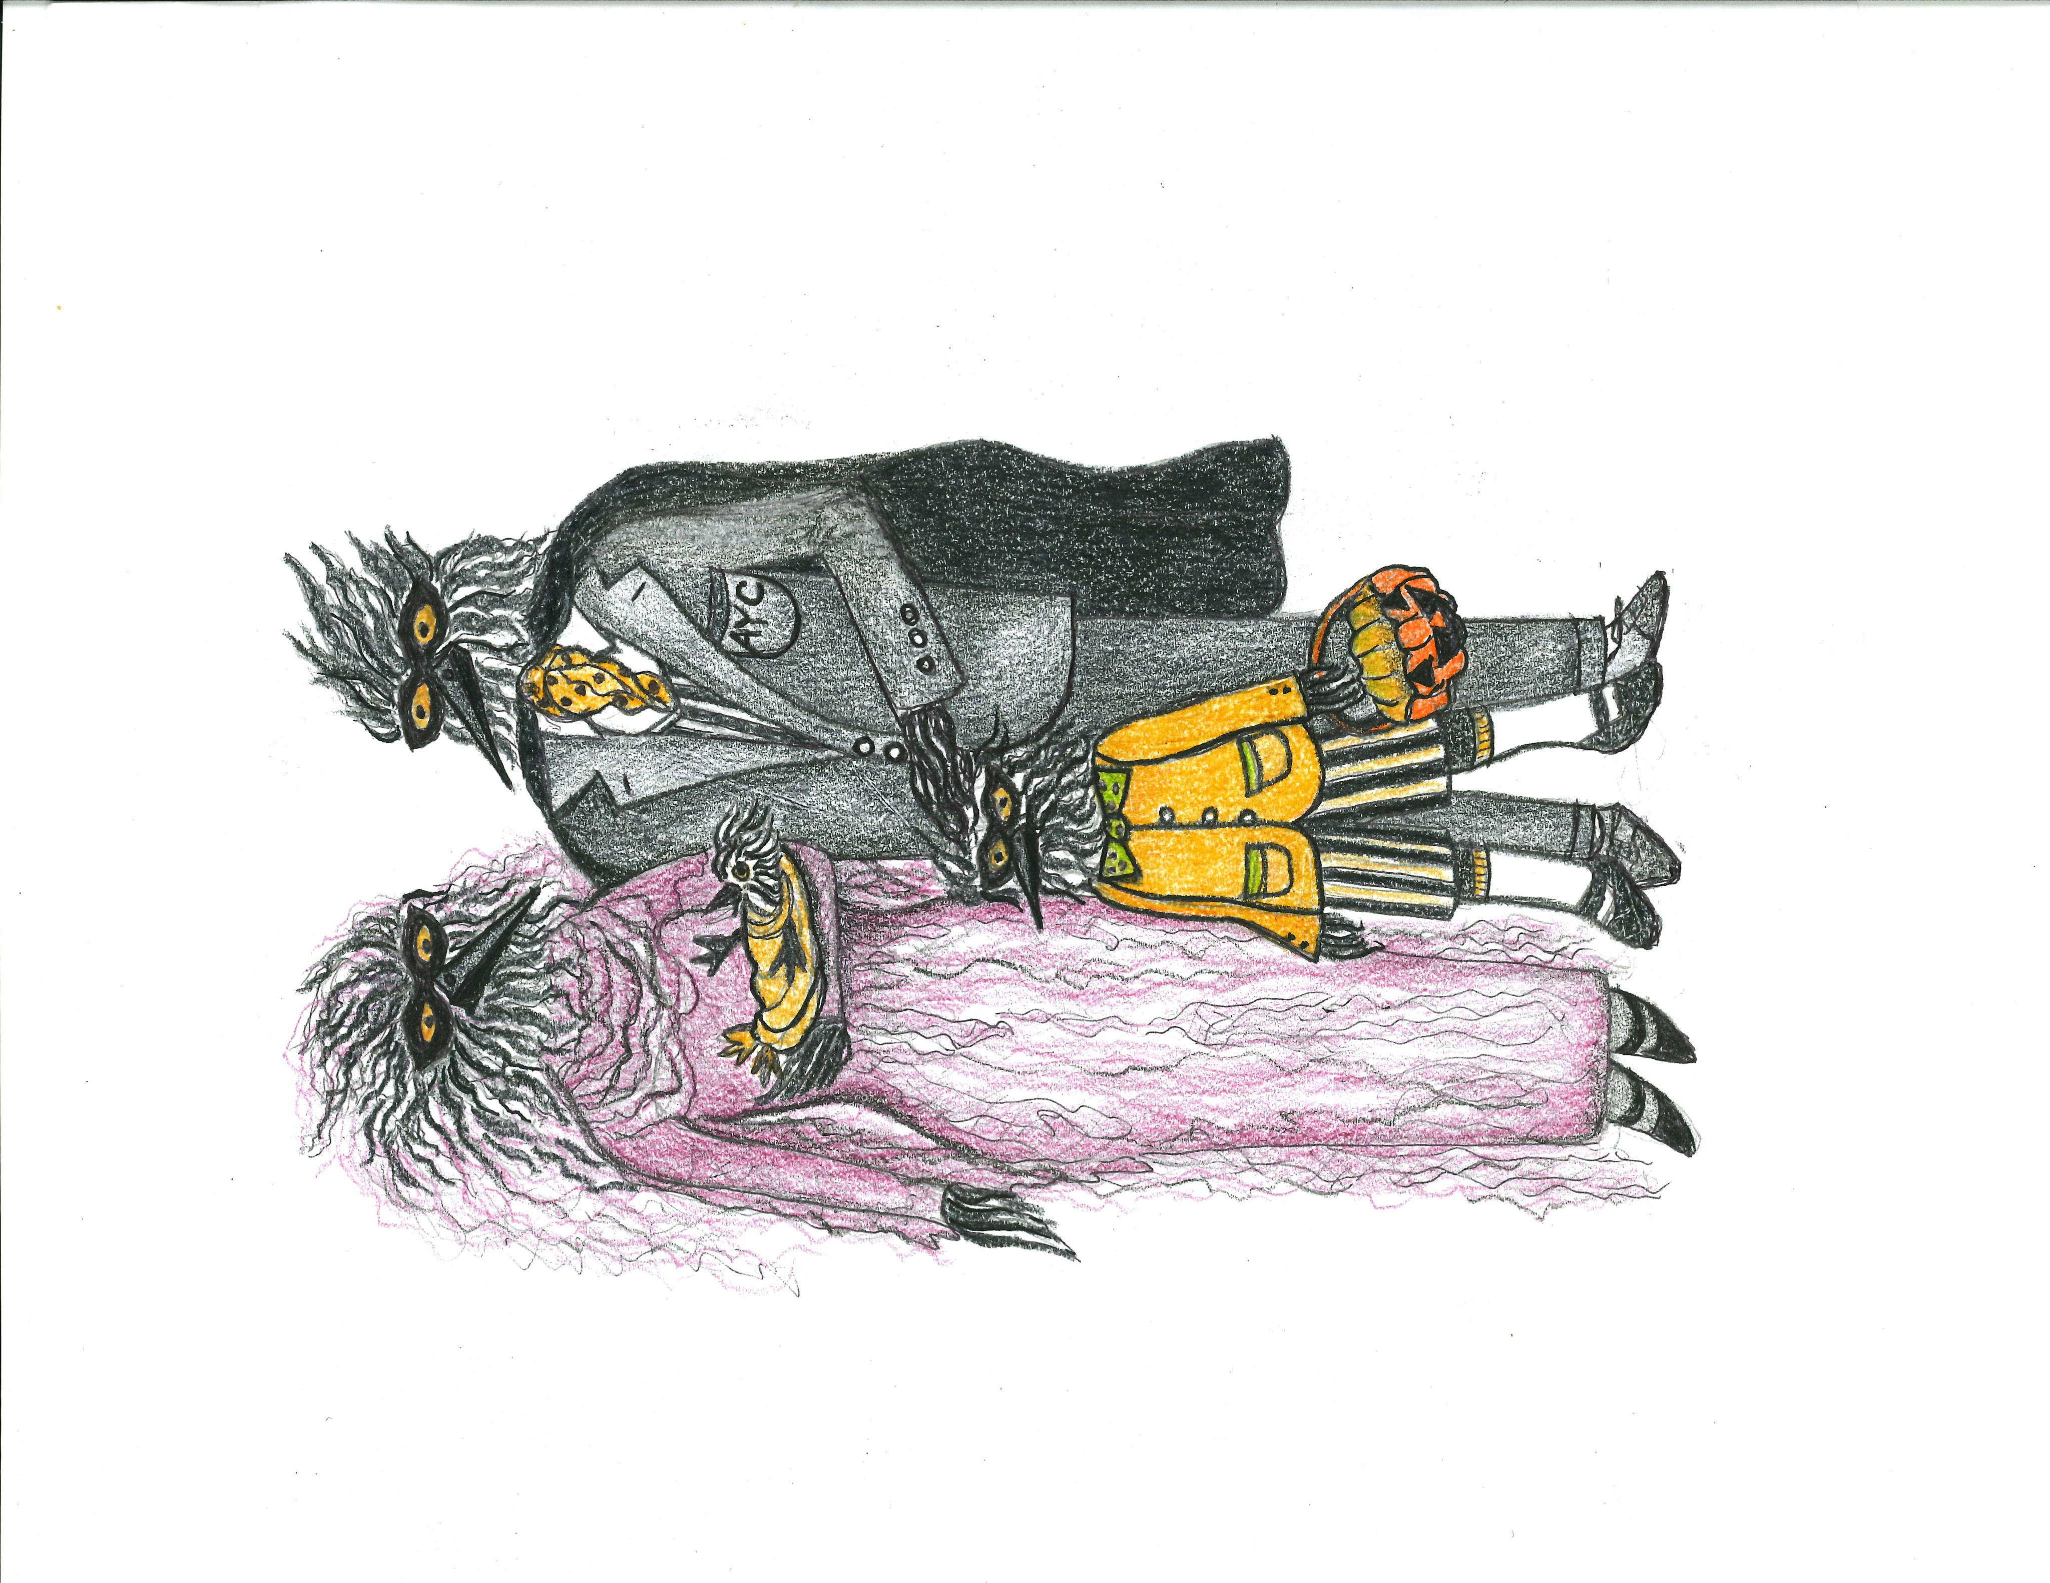

**The Notice of Race, Schedule of Events, Registration and Sailing Instructions will be posted on the AYC web site at**

[**http://www.atlantayachtclub.org/halloween**](http://www.atlantayachtclub.org/halloween)

**Register before Friday October 12 and receive 2 Event T Shirts.**

**Limited housing in private cabins on the AYC grounds is available on a first come first served basis after a participant has registered during the Pre-registration Period.**

**Limited Charter Boats will be available.**

**For further information re the events, housing and charter boats please contact Don Hackbarth at** [**dhackbarth@icloud.com**](mailto:dhackbarth@icloud.com)