Standard Sailing Instruction Template
In accordance with RRS Part. 7, 89.1(d) the organizing authority for all Class Championships and Sanctioned Regattas is the Snipe Class International Racing Association. Event Hosts (affiliated clubs or organizations) shall use these Sailing Instructions for all Championship and Sanctioned regattas. The Principal Race Officer (PRO) for the regatta shall fill in the appropriate information where requested as indicated by <___> or delete sections not relevant. Specific advice and directives are bracketed [*--*]. No additions or deletions to these instructions shall be permitted to alter the intent of the Class rules. No additions or changes shall be made without the prior approval of the regatta SCIRA Representative.

SAILING INSTRUCTIONS

SNIPE CLASS INTERNATIONAL RACING ASSOCIATION

<Name of the Regatta>
<Name of Deed of Gift Trophy>
<Date>
<Name of Yacht Club>
<Location>
1 RULES
1.1 The regatta will be governed by the rules as defined in The Racing Rules of Sailing.
1.2 No national authority prescriptions will apply or the following National prescription will apply <insert prescriptions>.
1.3 The Rules of Conduct for Conducting National and International Championship and The trophy restrictions of <insert the name of trophy and Deed of Gift> will apply. Any conflict arising between Deed of Gift and the SCIRA Rules of Conduct shall be solved by the application of Rules of Conduct.
1.4 In case of conflict between the Notice of Race and the Sailing Instruction the Sailing Instructions shall prevail.
1.5 If there is a conflict between languages the English text will take precedence.
2 NOTICES TO COMPETITORS
Notices to competitors will be posted on the official notice board(s) located at location(s)>.
3 CHANGES TO SAILING INSTRUCTIONS
3.1 Any change to the sailing instructions will be posted before <insert time> on the day it will take effect, except that any change to the schedule of races will be posted by <insert time> on the day before it will take effect.
3.2 Any change or amendment to the Sailing Instructions shall be approved with the SCIRA Representative.
4 SIGNALS MADE ASHORE
4.1 Signals made ashore will be displayed atlocation>.
4.2 When flag AP is displayed ashore, ‘1 minute’ is replaced with ‘not less than number minutes’ in the race signal AP.
(OR)
4.2 Flag D with one sound means ‘The warning signal will be made not less than number minutes after flag D is displayed. Boats are requested not to leave the harbour until this signal is made.’
4.3 When flag Y is displayed ashore, rule 40 applies at all times while afloat. This changes the Part 4 preamble.
5 SCHEDULE OF RACES
5.1 Dates of racing:
Date | Time of Warning Signal
______ | ________ | Practice race
______ | ________ | Racing
______ | ________ | Lay day
______ | ________ | Racing
______ |  | Reserve day
5.2 The Race Committee shall attempt to complete <insert number> races.
5.3 No more than three (3) races shall be sailed per day.
5.4 To alert boats that a race or sequence of races will begin soon, an orange flag will be displayed with one sound for at least four minutes before a warning signal is made.
5.5 On the last day schedule of racing no warning signal will be made after <Insert time>.
5.6 There may be a competitors meeting at <before each series, insert time and location> and announced by two <insert type of sound signals>.

6 CLASS FLAGS
The official Class Flag shall be the Snipe Class flag, a red Snipe on a white background.
7 RACING AREAS
Attachment number shows the location of racing areas.
(OR)
The Racing Area location chart is posted on the Official Notice Board
(OR)
The Racing Area location is <describe location>.
8 WEATHER LIMITATION (Course and Starting)
8.1 The wind speed ranges shall be no less than 5 knots and not exceed 23 knots or in accordance with the applicable Deed of Gift.
For Masters events the maximum wind speed allowed shall 15 knots.
For Women’s events the maximum wind speed allowed shall 18 knots.
8.2 Wind reading instruments shall be between 2 and 3 meter above the surface of the water. The duration of reading shall be 3 consecutive minutes prior the race warning. The wind reading shall be taken from an unobstructed area on the boat, it is recommended that there be a minimum 4 meters of free space surrounding the wind instruments. If during the race the wind speed goes over the maximum (23 knots) wind speed allowed for more than 3 consecutive minutes the race shall be abandoned (this change RRS 32.1).
9 THE COURSES
9.1 The diagrams bellow show the courses, including the approximate angles between legs, the order in which marks are to be passed. All course marks (except gates) shall be left to port.

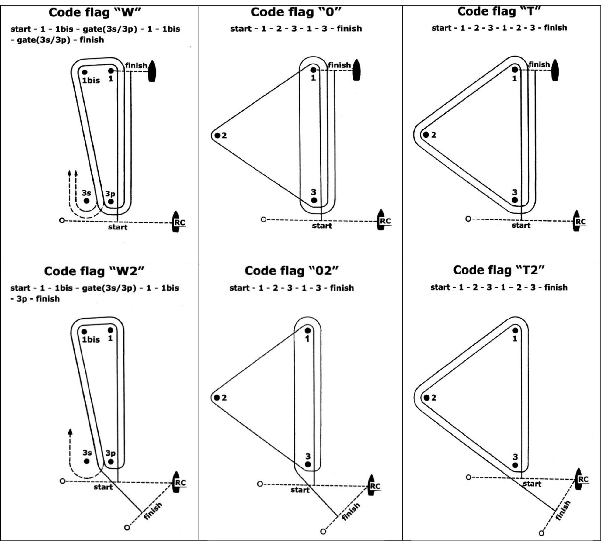

9.2 The course signal (code flag “W”, “T”, “O”, “W2”, “T2” or “O2”) shall be hoisted one minute before the warning signal and accompanied by one <insert sound>. It shall remain displayed for ten minutes after the start.
9.3 No later than the warning signal, the Race Committee signal boat will display the approximate compass bearing of the first leg.
9.4 If during a race the wind and/or wave action changes to the point where the selected course would be inadvisable (See Course Selection Diagram), the Race Committee shall change the course at any mark. A change of the type of course during the race shall be signalled displaying the new appropriate flag and accompanied by repetitive sounds before the leading boat has passed or rounded the mark.
9.5 The number of legs in a race may be reduced (RRS code flag S) but at least 2 (two) windward legs of the race shall be completed. This change RRS 32.2. [*The SCIRA Representative should be consulted.*]
9.6 A sustained wind variation of 20 degrees or more frorn the posted bearing during the first leg of a race shall result in the race to be abandoned and re-sailed, or abandoned. This change RRS 32.1.
9.7 A sustained wind variation of 40 degrees or more of the posted bearing during the first lap shall result in the race being abandoned and re-sailed, or abandoned. For the purpose of this rule a lap means the rounding of mark 3 (or passing the gate 3s/3p) for the first time.(This change RRS 32.1.
10 MARKS
10.1 Marks 1, 1bs, 2, 3, 3s and 3p will be marks>.
10.2 New marks, as provided in instruction 13.1, will be new.
10.3 The starting mark will be <Describe mark>.
10.4 The finishing mark will be <Describe mark>.
10.5 A race committee boat signalling a change of a leg of the course is a mark as provided in instruction 13.2.
11 AREAS THAT ARE OBSTRUCTIONS [*Optional*]
The following areas are designated as obstructions: obstruction
12 THE START
12.1 Races will be started by using RRS 26. number>
12.2 The starting line will be between an orange flag or shape on the Race Committee boat at the starboard end and the course side of the port end starting mark.
12.3 A boat starting later than 5 minutes after her starting signal will be scored Did Not Start without a hearing. This changes rules A4 and A5.
12.4 RRS 30.4 (‘Black Flag Rule’) shall not be used.
12.5 The Race Committee, after the finish of a race and before the warning signal of a subsequent one, will do it’s best to post on the Race Committee boat a list of OCS and/or ZPF boats. The failure of posting or an incomplete or wrong list will not be grounds for redress.
13 CHANGE OF THE NEXT LEG OF THE COURSE
13.1 Changes to the next leg of the course shall be made using RRS 33. To change the next leg of the course, the race committee will lay a new mark (or move the finishing line) and remove the original mark as soon as practicable. When in a subsequent change a new mark is replaced, it will be replaced by an original mark.
13.2 Except at a gate, boats shall pass between the race committee boat signalling the change of the next leg and the nearby mark, leaving the mark to port and the race committee boat to starboard. This changes RRS 28.1.
13.3 After the completion of first windward leg of the race the remaining legs may be increased or decreased (RRS 33 + - ) by not more than 30% of original length. This changes RRS 33). [*The SCIRA Representative should be consulted on any change of course which affects its length.*]
14 THE FINISH
14.1 The finish line will be between an orange flag or shape on a Race Committee boat and the course side of the finishing mark.
14.2 The Alfa flag on the Race Committee boat at the finish means that there will be no more races for the day.
15 PENALTY SYSTEM
15.1 Appendix P will apply.
15.2 [*Optional*] Any competitor using an one/two turn(s) penalty shal report that use to the Race Committer promptly upon finishing that race.
16 TIME LIMITS AND TARGET TIMES
16.1 The races will be managed to last 60-75 minutes for the first boat to finish. A different time (shorter or longer) used to complete the race will not be ground for requesting redress.
16.2 The time limit for the first boat to complete the first lap is 40 minutes from the start. If the first boat fails to complete the first lap within 40 minutes the Race Committee shall abandon the race. For the purpose of this Rule a lap means the rounding of Mark 3 (or passing the Gate 3s/3p) for the first time.
16.3 The time limit for the first boat to finish the race shall be 1 hour, 30 minutes. Any boat finishing more than 30 minutes after the first boat sails the course and finishes or failing to finish within 2 hours from the start, whichever is shorter, shall be scored Did Not Finish (DNF). This changes RRS 35, A4 and A5.

17 PROTESTS AND REQUESTS FOR REDRESS
17.1 Protest forms are available at the race office, located at location>. Protests and requests for redress or reopening shall be delivered there within the appropriate time limit.
17.2 The protest time limit is 90 minutes after the last boat has finished the last race of the day or the race committee signals no more racing today, whichever is later.
17.3 Notices will be posted no later than 30 minutes after the protest time limit to inform competitors of hearings in which they are parties or named as witnesses. Hearings will be held in the protest room, located at location>, beginning at the time posted.
17.4 Notices of protests by the race committee or protest committee will be posted to inform boats under rule 61.1(b).
17.5 Within the protest time limit, a list of boats that have been penalized for breaking rule 42 or rules 29 and 30 will be posted.
17.6 Any boat intending to file a request for redress, alleging that an action or omission on the part of Race Committee has made her finishing position or series score significantly worse, shall notify the Race Committee immediately after finishing that race. This modifies RRS 62.2. This instruction does not apply to request for redress resulting from scoring penalties applied without a hearing by the Jury or Race Committee or to request for redress with respect to alleged scoring errors.
17.7 Breaches of instructions 19, 20.3, 21, 22, 24 and NoR 3.4 (bow numbers) will not be grounds for a protest by a boat. This changes rule 60.1(a). Penalties for breaches of SI 24 may be less than disqualification or will result in denial of access of the coach boats, if the protest committee so decides. The penalty for breaking SI 19, 22 and NoR 3.4 (bow numbers) shall be the 5% scoring penalty for nearest race completed by the infringing boat but not worse than the number of points corresponding to DSQ. Penalties for breaking Class Rules, or SI 21, may be less than disqualification. The scoring abbreviation for a discretionary penalty imposed under this instruction will be DPI.
17.8 On the last scheduled day of racing a request for reopening a hearing shall be delivered
(a) within the protest time limit if the requesting party was informed of the decision on the previous day;
(b) no later than 30 minutes after the requesting party was informed of the decision on that day.
This changes rule 66.
17.9 On the last scheduled day of racing a request for redress based on a protest committee decision shall be delivered no later than 30 minutes after the decision was posted. This changes rule 62.2.
17.10 [*For regattas employing an international jury*] An International Jury is constituted and is approved by SCIRA and shall have authority per RRS Appendix N. Their decision shall be final as provided in rule 70.5. Per rule N2.2, SCIRA reserves for itself the right and responsibility to decide issues of eligibility, measurement and equipment. SCIRA may refer any issue to the International Jury for advice.
17.11 The use of team racing tactics shall not be tolerated. If the Race Committee (acting under RRS 32.1(e)) or the Protest Committee determines that the use of team racing tactics may have significantly influenced the outcome of a race they shall order that race abandoned and, if possible, re-sailed excluding the participation of the infringing boat(s). This modifies RRS 36. If the race is not re-sailed the infringing boat(s) shall be subject to protest and disqualification.
17.12 For the purpose of rule 64.3(b) RRS the “authority responsible” is the Measurer of the event.
17.13 The Jury shall abandon the race if, during a redress hearing, they conclude that the Race Committee did not follow Sailing Instructions 8.1, 8.2, 9.5, 9.6, 9.7, and 13.3. This changes rule 64.2.
18 SCORING
18.1 number> races are required to be completed to constitute a series. [*per SCIRA Rules, Deed of Gift, etc.*]
18.2 (a) When fewer than number> races have been completed, a boat’s series score will be the total of her race scores.
(b) When from number> to number> races have been completed, a boat’s series score will be the total of her race scores excluding her worst score.
(c) When number> or more races have been completed, a boat’s series score will be the total of her race scores excluding her two worst scores.
18.3 A boat intending to retire and be scored “RET” shall report its intent in writing to the Jury
19 SAFETY REGULATIONS
19.1 Before the warning signal of the first race of the day each boat is required to sail past the stern of the <insert description> Race Committee boat on starboard tack and verbally check in. The check-in boat will display a <insert flag description> while on station prior to the first warning signal. If no separate check-in boat is on station competitors will check in with the main Race Committee boat. When the Race Committee verbally acknowledges a boat’s <insert sail or bow> number, the check-in has been officially noted.
(OR)
19.1 Check-Out and Check-In: any.
19.2 A boat that retires from a race shall notify the race committee as soon as possible.
20 REPLACEMENT OF CREW OR EQUIPMENT
20.1 The same crew shall race in all races, except for reasons satisfactory to the Race Committee. Requests for a change of crew shall be submitted in writing to the Chairman. Once a crew has been excused, he/she may not return for the balance of the series.
20.2 The same skipper shall sail all races and can be replaced after the first race only, and then only if he/she is obviously incapacitated. If a skipper is replaced the first race shall be the race dropped, or scored DNC.
20.3 Substitution of damaged or lost equipment will not be allowed unless authorized by the Race Committee. Requests for substitution shall be made to the Race Committee at the first reasonable opportunity.
21 EQUIPMENT AND MEASUREMENT CHECKS
A boat or equipment may be inspected at any time for compliance with the class rules and sailing instructions. On the water, a boat can be instructed by a Race Committee equipment inspector or measurer to proceed immediately to a designated area for inspection.
22 EVENT ADVERTISING
Boats shall display event advertising supplied by the organizing authority as follows:
necessary.

23 RIGHTS TO USE NAME AND LIKENESS
By participating in this event, competitors automatically grant to the SCIRA, organizing authority and the event sponsors the right, in perpetuity, to make, use, and show, at their discretion, any photography, audio and video recording, and other reproductions of them made at the venue or on the water from the time of their arrival at the venue, until their final departure, without compensation.
24 OFFICIAL BOATS
Official boats will be marked as follows: markings>.
25 SUPPORT BOATS
25.1 Team leaders, coaches and other support personnel shall not go afloat in the racing area during the racing except upon Race Committee designated spectator boats. The Race Committee may initiate additional restrictions by posting them on the Official Notice Board.
(OR)
25.1 At the warning signal, coaches must be positioned at least 50 meters below the starting line. After the starting signal coaches may follow the fleet, but only on the port side of the course and must stay 50 meters from any mark
25.2 Coaches may not communicate with competitors after the warning signal for any race until after the competitors have finished of the race.
25.3 Coaches shall register at the Regatta Office and all support boats shall be identified <insert how to identify>.
26 TRASH DISPOSAL
Trash may be placed aboard support or official boats.
27 PRIZES
Prizes shall be awarded as provided by NoR.
28 DISCLAIMER OF LIABILITY
Competitors participate in the regatta entirely at their own risk. See rule 4, Decision to Race. The organizing authority will not accept any liability for material damage or personal injury or death sustained in conjunction with or prior to, during, or after the regatta.
29 INSURANCE
Each participating boat shall be insured with valid third-party liability insurance with a minimum cover of currency per incident or the equivalent.

Signatures: [* The Sailing Instruction must be signed by the Race Committee Chairman or Principal Race Officer and also the SCIRA Representative*]

<insert name> - Race Committee Chairman <insert name> - SCIRA Representative

Optional Addendum
(Large Fleets)
[*any or all of these options may be used*]

The Start:

11.6 Mid-line boat
11.6.1 The starting line shall be between an orange flag or shape on the Race Committee boat on the starboard line end and passing through an orange flag or shape on the mid-line boat and ending at the line flag or the course side of the port end starting mark. The mid-line boat is a starting mark surrounded by navigable water. Should the mid-line boat be removed, the line shall be defined by the previously described line ends.
11.6.2 For the purpose of RRS 28.1 and 30.1, the extensions of the starting line are beyond the port and starboard line ends.
11.6.3 RRS 31.2 is modified such that when a boat touches the mid-line boat and infringes RRS 30.1, she shall exonerate herself by completing one rounding of either line end and restarting.
11.7 The Race Committee may set a guidance marker on or below the starting line. If set, such a marker is neither a part of the starting line, nor a mark of the course.

Scoring:
18.3 (Optional for drop race regattas)
RRS 62 is modified such that a violation of RRS 29.1 (OCS) may not be dropped if unsuccessfully contested by the infringing competitor and shall be scored DNE.

