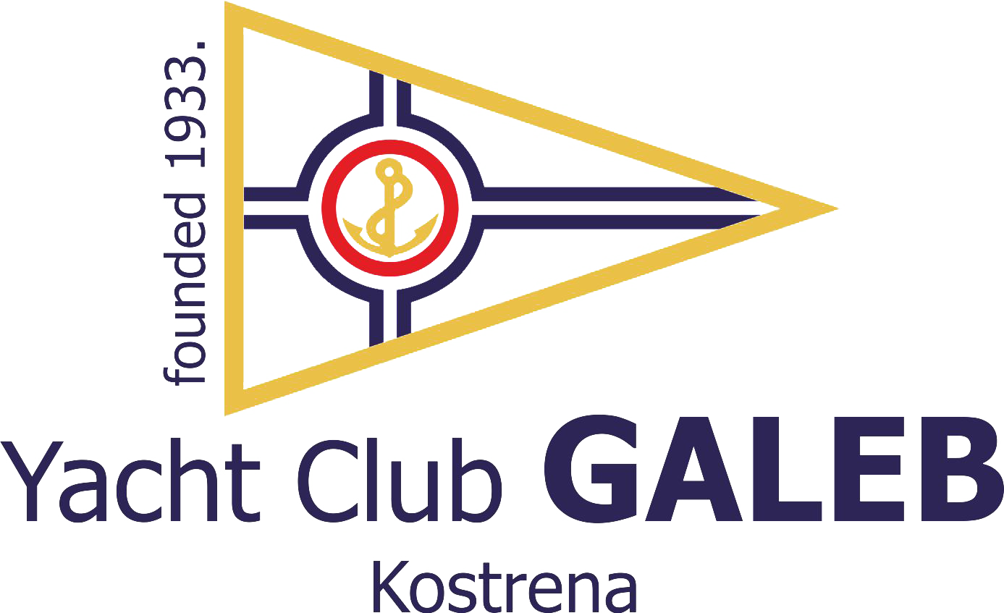

NOTICE OF RACE
PROLJETNI KUP GALEBA/GALEB SPRING CUP
Optimist , Laser 4.7, Laser Radial
Snipe

Kostrena, Croatia, April 25-26, 2015.

1. Organizing Authority
Yacht Club „Galeb“;
Uvala Žurkovo 2/3; 51221 Kostrena, Croatia

2. Racing Area
Bay of Rijeka

3. Rules
Racing Rules of Sailing 2013-2016(RRS), Class rules for the respective competing classes, Sailing Instructions. If there is a conflict, Sailing Instructions and Croatian language will take precedence.

4. Eligibility
The regatta is open to all the sailors bearing verification at their respective national Authorities for the year 2015. and each boat shall produce a valid measurement certificate.

5. Entry and Fees
Eligible boats may enter by completing the attached form and mailing/faxing it by April 25, 2015 to the address: Jedriličarski klub “Galeb“, Uvala Žurkovo 2/3; 51221 Kostrena, tel/fax 051/400-308; or sending to e-mail:jedrilicarski.klub.galeb@ri.t-com.hr, or by submiting in person to the Regatta Committee on Saturday, April 25, 2015 from 8.00am until 9.30am. There is no starting fee.

6. Schedule of races
Saturday, April 25, 2015
11:00 Start of the first race – remaining races will follow in due course
Sunday, April 26, 2015
10:00 Start of the first race

7. The Courses
Trapezoidal course will be used.

8. Scoring
Total of 5 races are planned. When fewer than 4 races have been completed, a boat’s series score will be the total of all her race scores. When from 4 to 5 races have been completed, a boat’s series score will be the total of her race scores excluding her worst score. Regatta will be valid if at least one race is completed.

9. Prizes
Prizes will be given to the first three boats and additional prize is awarded to the first female crew in each of the classes. Organizing authority retains the right to expand the prize list.

10. Disclaimer of Liability
Competitors participate in the regatta entirely at their own risk. See rule 4, Decision to Race. The organizing authority will not accept any liability for material damage or personal injury or death sustained in conjunction with or prior to, during, or after the regatta.

YACHT CLUB “GALEB”
Uvala Žurkovo 3; 51221 Kostrena jkgaleb@ri.htnet.hr; tel/fax 051/400-308

PROLJETNI KUP GALEBA GALEB SPRING CUP
Optimist , Laser 4.7 , Laser radial , Snipe

Kostrena, Croatia, April 25-26, 2015
PRIJAVA - ENTRY FORM
KLASA / CLASS_________________________JEDR. KLUB/SAILING CLUB:

No. | Name and Surname | Gender M/F | Year of Birth | Sail No.
Suglasan sam poštovati Regatna pravila 2013-2016, Oglas za regatu, Upute za regatu i sva ostala pravila po kojima se održava ova regata.
I accept The Racing Rules of Sailing for 2013-2016, Notice of Race, Sailing Instructions and all other rules valid for this race.
MJESTO / PLACE
DATUM / DATE
POTPIS / SIGNATURE

