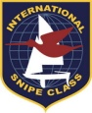 | SOUTH EUROPEAN CHAMPIONSHIP 2014

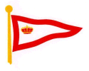 | REAL CLUB ASTUR DE REGATAS  GIJÓN, SPAIN

Real Club Astur de Regatas (RCAR) has been chosen by the Snipe Class International Racing Association (SCIRA) to host in Gijón, Spain, the South European Championship next august 30-31, 2014, together with the XV Carlos del Castillo Memorial Trophy.

Real Club Astur de Regatas (RCAR) hosts the event for the second time, after hosting the championship in 1992. That year the event took place in june and the winners were argentinians Santiago Lange and Mariano “Cole” Parada, who would eventually win the following two world championships, in 1993 and 1995.

1992. Gijón, Spain | 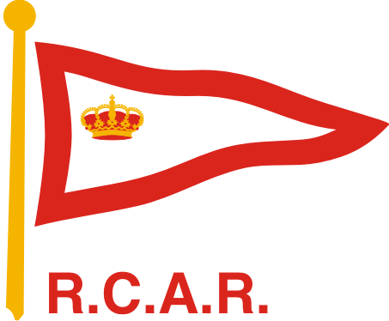

- Santiago Lange & Mariano Parada
- Carlos Llamas & Javier Gutierrez
- Tiago Roquete & Pedro Ambrosio

RCAR will soon distribute the Notice of Race and looks forward seeing many snipe sailors in Gijón again.

SERIOUS SAILING, SERIOUS FUN ®

RECENT HISTORY OF THE SNIPE SOUTH EUROPEAN CHAMPIONSHIP

2008. Cervia, Italy | 

- Jordy Triay & Garrido Borja
- Bruno Bethlem & Roberto Paradeda
- Augie Diaz & Kathleen Tocke
2009. Caldonazzo, Italy | 

- Fabio Rochelli & Daniela Semec
- Paolo Lambertenghi & Antonio Bari
- Enrico Michel & Maria Bellemo

2010. Omišalj, Croatia

- Bart Janssens & Eva Jacobs
- Pietro Fantoni & Stefano Longhi
- Fabio Steffe & Stefano Bosotti

2011. Bracciano, Italy | 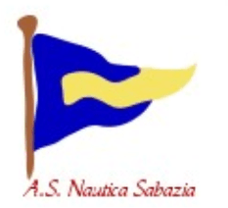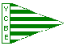

- Giampiero Poggi & Eugenia Vanni
- Andrea Zaoli & Davide Ortelli
- Enrico Michel & Randi Stray

2012. Caldonazzo, Italy

- Manu Hens & Enrico Michel
- Bart Janssens & Eva Jacobs
- Ben Van Cauwenbergh & Nadia Deferm

2013. Sanremo, Italy | 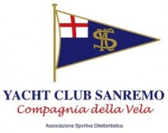

- Enrico Solerio & Sergio Simonetti
- Chiara Magliocchetti & Erica Ferraris
- Paolo Lambertenghi & Marco Rinaldi

