2014 Snipe North American Championships
August 15-17th
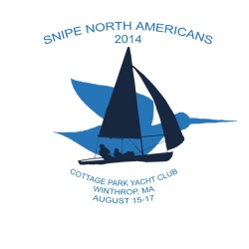
Cottage Park Yacht Club
Winthrop.MA

The wind gods favored the 2014 Snipe North American Championships with three days of good wind and fair weather enabling the 37 competitors to do battle in eight races over the three days of the event. Winds tended to be light early in the day building as each day progressed testing the sailor’s endurance in lumpy seas. Numerous shifts challenged both the race committee and the sailors. Starts were progressively aggressive as the racing progressed causing the “I” flag to come into play.

Congratulations go to Ernesto and Eduardo Rodriquez for winning the 2014 Snipe North American Championships and the Birney Mills Trophy and the Kim Thompson Perpetual Trophy respectively. Consistently finishing in the top 5 in every race they took three bullets to finish one point ahead of Augie Diaz and Aine Fretwell. Raul Rios and Chris Dwyer finished a close third and won the Chuck Loomis Junior Trophy.

Youth in sailing were a major aspect of this year's event. Of the 37 teams, 6 teams were SCIRA juniors (under 22 years old by year's end), a dozen and half of all sailors were junior-grade and half a dozen were "recent graduates" of the junior grouping (i.e. under 30). This was a major contributor to the late night bowling at the club’s candlepin lanes and dancing to the DJ on Saturday night.
The event was highlighted by a traditional New England Lobster and Sirloin Roast Dinner on Saturday night prepared completely by Cottage Park Yacht Club volunteers.

Pictures are by club member Eric Kirton

