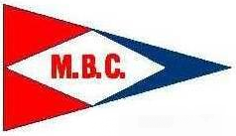 | Sail to a Cure!  saturday July 26th 2014  10am – 6pm | 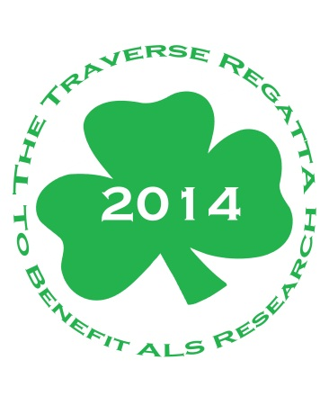
MEDFORD BOAT CLUB
in partnership with
will host an ALS Reasearch Fundraiser

Sailors will be racing in honor of Chris Traverse, a lifetime Medford Boat Club sailor dedicated to the development of the MBC Sail Program, who has been diagnosed with ALS, a progressive neurodegenerative disease.

Race: Registration is open to anyone under 21 (any age for the Snipe class). We hope to draw approximately 100 sailors aged 8-21 from Greater Boston.
Fleets: N-10’s, 420’s, Lasers, Snipes, and Optimists.

Register: http://community.als.net/TraverseALSRegatta or
http://www.regattaman.com/jr_reg1.php?race_id=303&yr=2014&op=select

Make a Donation: You can make a 100% tax deductible donation to ALS TDI through this event at community webpage link. All donations to ALS TDI will help fund ALS TDI’s mission to find a cure for ALS.

