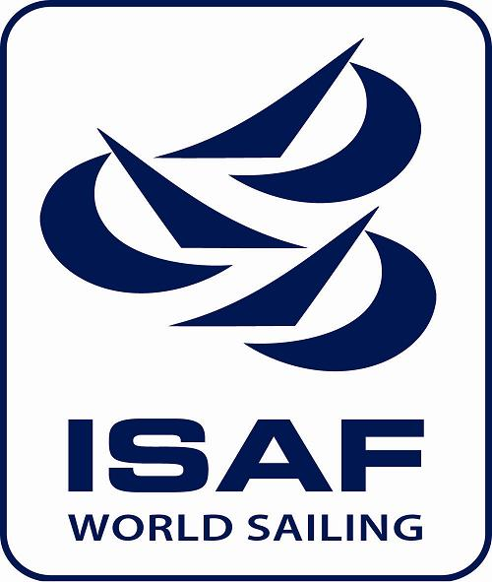 | 
Portorož Cup 2014
Dinghy 12’ & Snipe

31 May – 1 June 2014
Portorož - Portorose, Slovenia

ENTRY FORM
Boat name: |  |  | Modern Classic
Sail No.: |  | Club:
Insurance company: |  | Policy No:
Helmsman
Date of birth: |  | M F | Jun Mas > 60 S Mas > 70
National Authority licence. No.:
Bowman:
Date of birth: |  | M F | Jun Mas > 60 S Mas > 70
National Authority licence No.:
Address:
Mobile phone No.: |  | Fax No.
E-mail:

I agree to be bound by the ISAF Racing Rules of Sailing and all other rules that govern this event. I understand the Organising Authority accepts no responsibility for loss of life or injury, or for the loss of, or damage to, any vessel or equipment. I also declare to take any responsibility upon myself for damages caused to third persons and their things both on the land and on the sea in consequence of my taking part at this Regatta.
I declare that I have a current certificate of insurance which covers me while racing.

Date: |  | Signature:

____________________________________________________________________________________________
For Official Use:

Entry form received via:____________________ on ___________________ Signature:

Entry fee in amount ________________ received via:_________________ on ________________ Signature:

