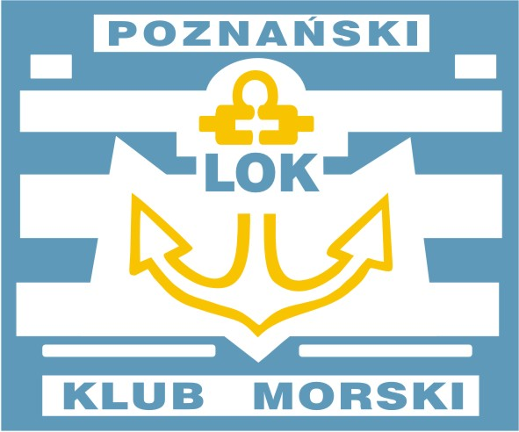
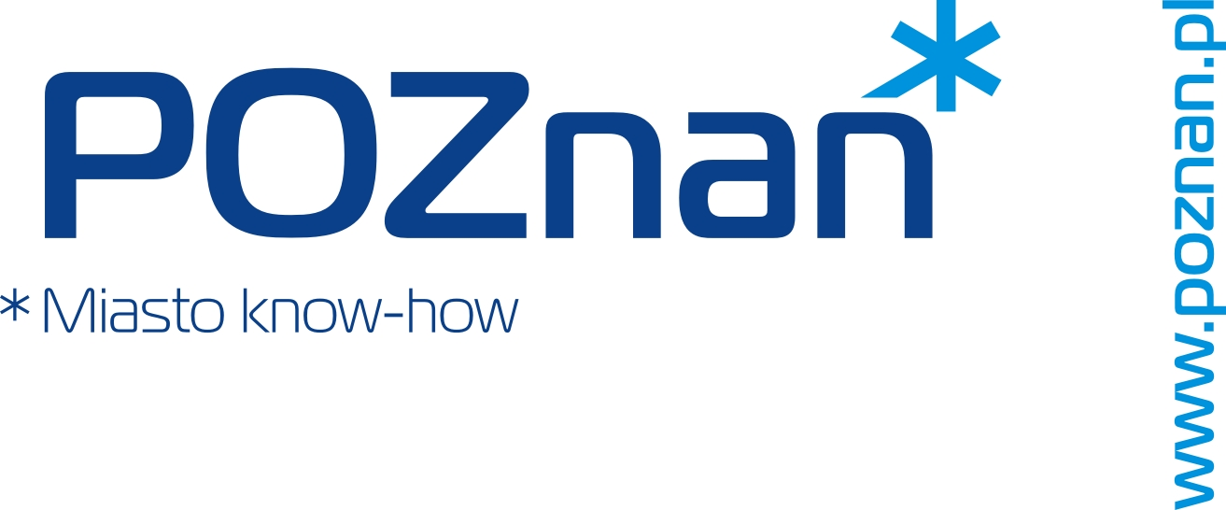
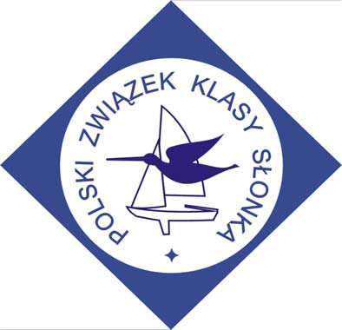
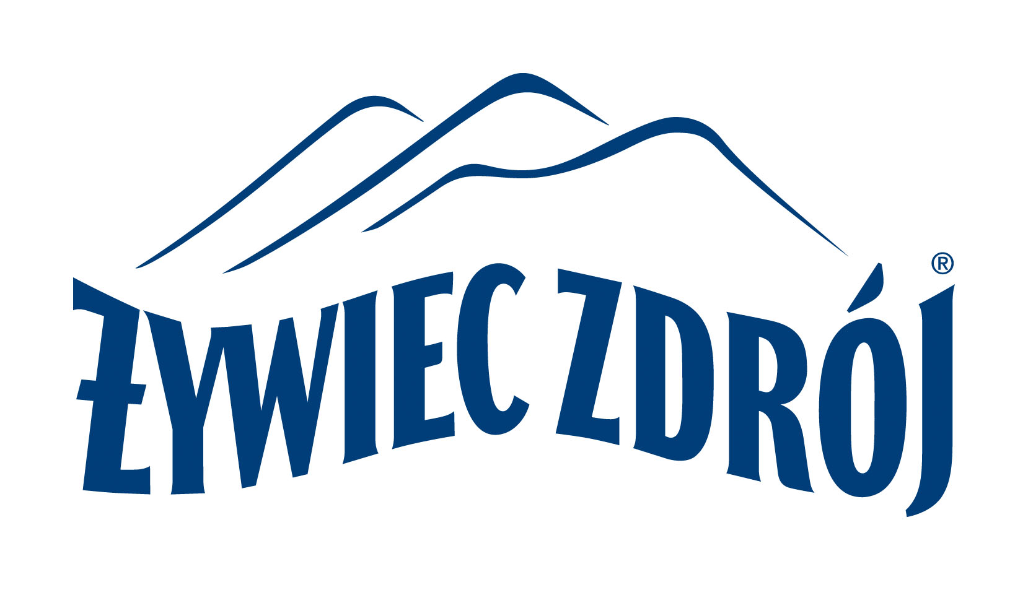

POLISH OPEN CHAMPIONSHIPS
SNIPE CLASS 2012
24-26 AUGUST 2012 POZNAŃ-POLAND
www.snipe.com.pl

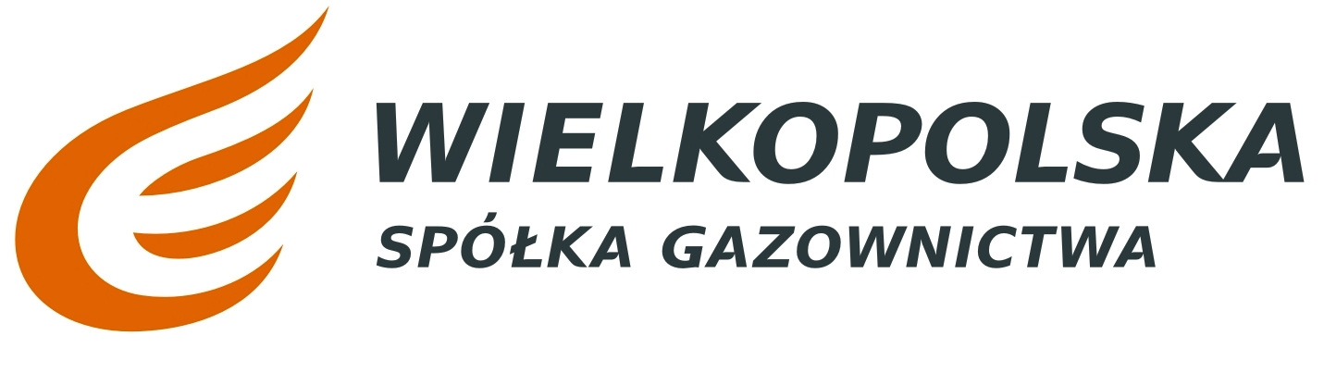

Entries are to be made on this ENTRY FORM and to be sent to:

Polish Snipe Class Association
Wilków Morskich 17/19
60-480 Poznań POLAND
e-mail: zrakocy@wp.pl , d.sibilski@op.pl
tel/fax + 48 61 8482681 or 61 8482691

BOAT NO:____________ SAIL NO:_____________ NATIONALITY:_______________

NAME OF SKIPPER:________________________________________________________

ADDRESS:_______________________________________________________________

E-MAIL:_________________________________________________________________

DATE OF BIRTH: (dd.mm.yy )_____________YACHTCLUB:_____________________

NAME OF CREW:__________________________________________________________

ADDRESS:__________________________________________________________________

DATE OF BIRTH:( dd.mm.yy )______________ YACHTCLUB:___________________

FINAL DAY OF INSCRIPTION August 24. 2012.

