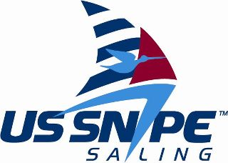

Miami Snipe Invitational
January 5-8, 2012

Skipper Name:

Age in 2102:
Hometown:
School Attending (or attended):
Yacht Club/Sailing Association:
Email:
Cell Number: Member of the Snipe Class?

Crew Name:

Age in 2012:
Hometown:
School Attending (or attended):
Yacht Club/Sailing Association:
Email:
Cell Number: Member of the Snipe Class?

- Will you need a charter boat?

- Do need housing?

- Will you have a car in Miami?

- Has either team member sailed a Snipe before?

- T-shirt sizes (men’s & women’s SM - XL):

- Are you planning on attending the clinic, Jan. 5-6?

- Arrival & departure dates (Airport?):

