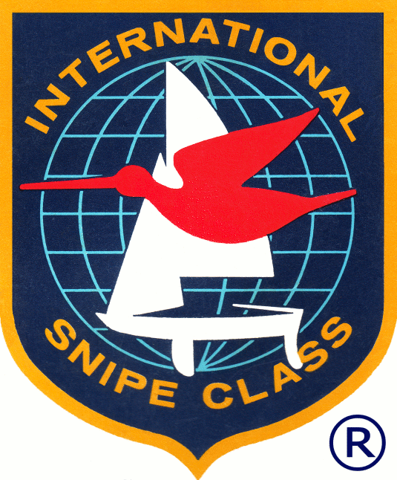

SCIRA Coaching Application

SCIRA is establishing a coaching database to provide clinics to developing nations and fleets with limited coaching resources. To be considered for the database, please complete and return to: scira@snipe.org for consideration.

First Name | Last Name
Nationality: | Year of Birth/Age: | Gender:
Email: | Mobile:
Current living in (country): | Languages spoken:
DESCRIBE YOUR COACHING EXPERIENCE:

