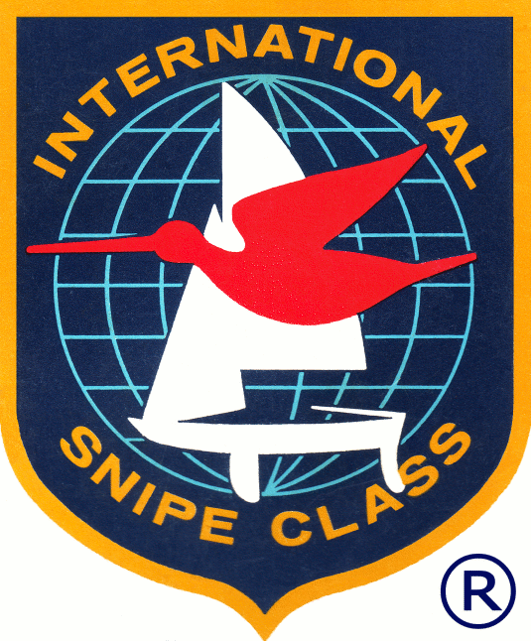

National Clinic Application Request

SCIRA is establishing a coaching database to provide clinics to developing nations and fleets with limited coaching resources. To be request a clinic, please complete and return to: scira@snipe.org for consideration.

Nation | Location of clinic
Main Contact Name | Surname
Preferred dates: | Approximate Age of sailors to be coached: | Number of sailors/boats in Clinic:
Email: | Mobile:
Language(s) spoken by participants:
DESCRIBE YOUR CLINIC NEEDS:

